1. ROLAP star schema for Fudgeworld in ist722_hhkhan_ob2_dw

1. ETL – OLTP to staging

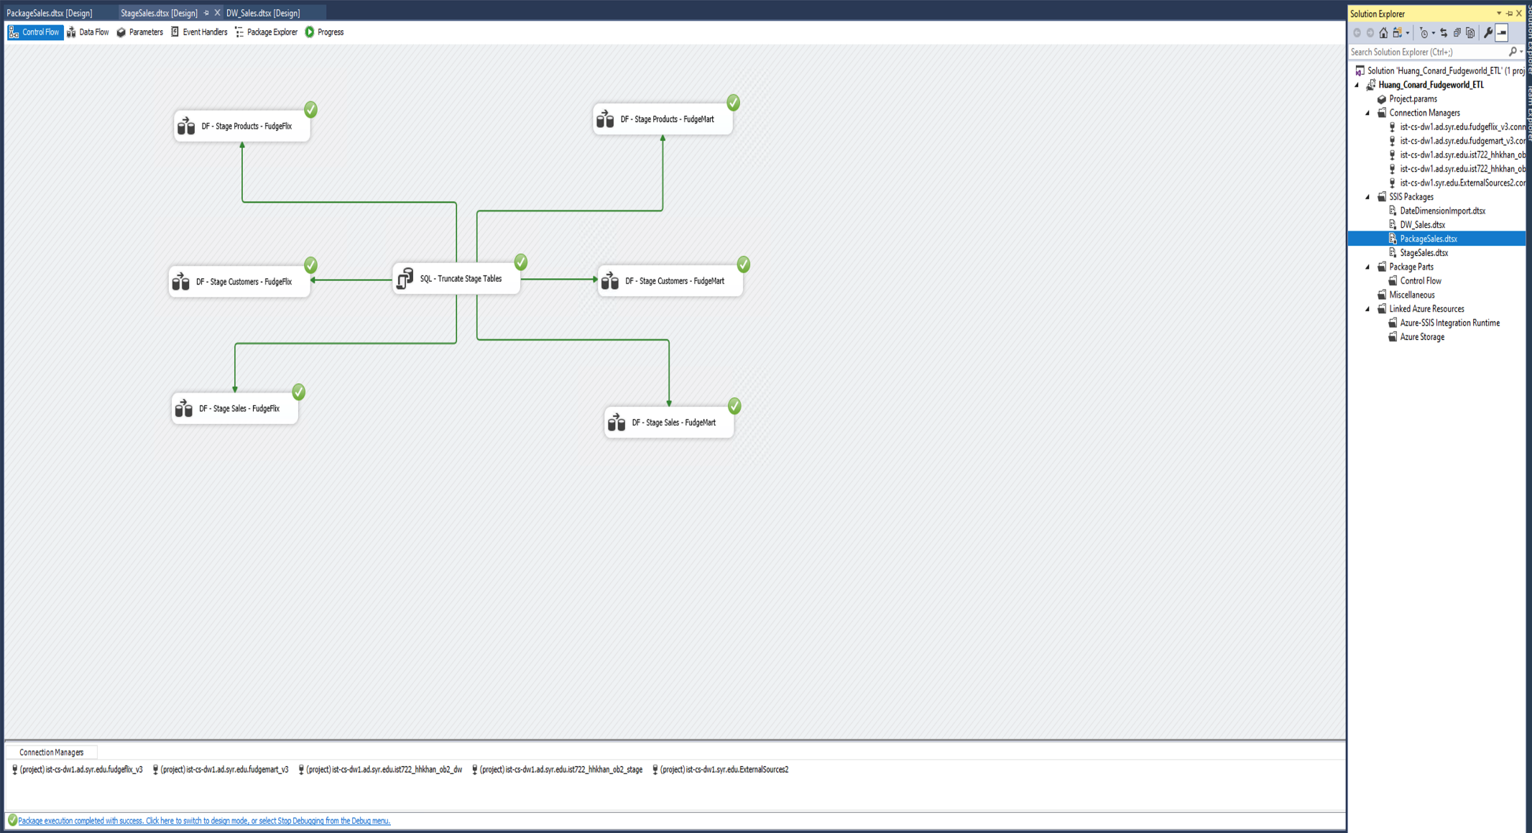

1. ETL staging to DW

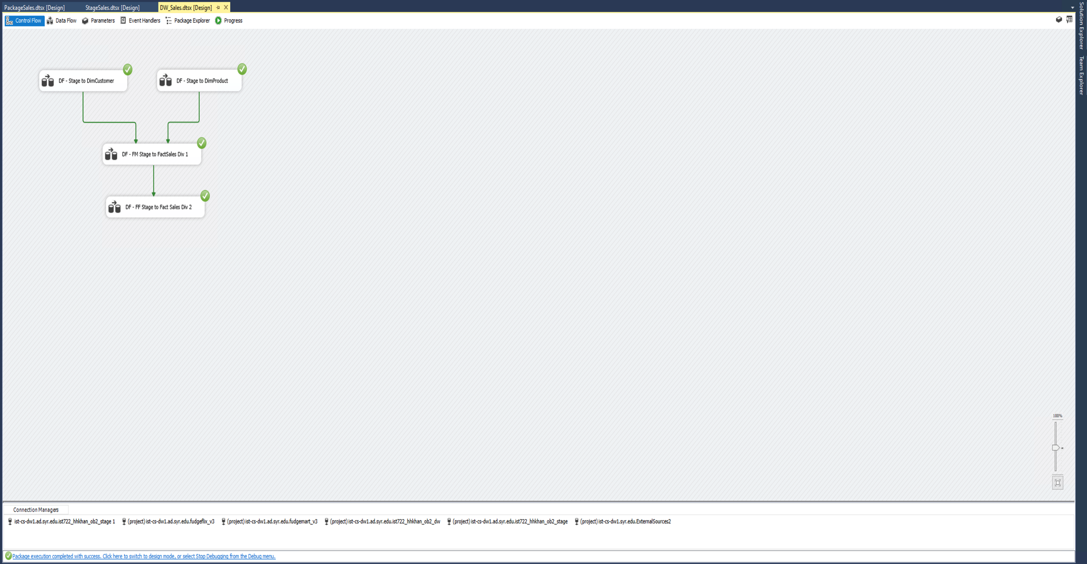

1. MOLAP star schema for Fudgeworld

